

**Caregiver Benefits Application (10-10CG)**

**Version 1.2  
Last Modified: July 11, 2024**

**Table of Contents**

**Caregiver Benefits Application Overview** **2**

**User Access** **2**

**Who can access this application?** **3**

**Navigation** **4**

**Maintenance Windows** **6**

**How Do I Apply?** **7**

**Program of Comprehensive Assistance for Family Caregivers (PCAFC) Application** **10**

**Veteran Information** **10**

**Veteran Health Care Information** **15**

**Primary Family Caregiver Selection** **17**

**Primary Family Caregiver Information** **19**

**Secondary Family Caregiver Selection** **24**

**Secondary Family Caregiver Information** **27**

**Additional Secondary Family Caregiver Information 31**

**Representative Documentation** **35**

**Review and Submission** **41**

**Reviewing the Application** **41**

**Signature Section** **44**

**Submitting the Application** **47**

**Troubleshooting a Submission Error** **49**

**Table of Figures** **51**

**Revision History** **53**

# **Caregiver Benefits Application Overview**

VA’s Program of Comprehensive Assistance for Family Caregivers (PCAFC) provides support and services to caregivers of eligible Veterans who have incurred a serious injury in the line of duty either on or after September 11, 2001, or on or before May 7, 1975.

To apply for PCAFC, Veterans and Family Caregivers must complete VA Form 10-10CG. This product guide provides instruction on the application process for online submission. The online application can be used to apply with a Primary Family Caregiver, and/or up to two Secondary Family Caregivers. The online form can accommodate applications with:

* Veteran and Primary Family Caregiver
* Veteran, Primary Family Caregiver, and Secondary Family Caregiver
* Veteran, Primary Family Caregiver, Secondary Family Caregiver, and additional Secondary Family Caregiver
* Veteran and Secondary Family Caregiver
* Veteran, Secondary Family Caregiver, and additional Secondary Family Caregiver

The application supports the ability for Veterans with a legal representative (such as legal guardian) to complete the online application. Representatives will be able to upload their documentation and sign their name on behalf of the Veteran.

VA’s Caregiver Support Program offers a wide variety of support services for caregivers of Veterans. Partnerships continue to be created or enhanced to broaden services and support for caregivers. Learn more by visiting the [Caregiver Support Program](https://www.caregiver.va.gov/) website or by calling the Caregiver Support Line at 855-260-3274 for more information.

## **User Access**

### **Who can access this application?**

This application is completed by Veterans and Family Caregivers. Each application can include a Primary Family Caregiver and up to two Secondary Family Caregivers.

Veteran information is required for every application, and each Family Caregiver applicant will need to complete their own section of the form. The Veteran and all Family Caregivers are required to check confirmation boxes on the submission page.

Unlike other forms on VA.gov, applicants do not sign in to complete the online version of the 10-10CG. You can reference Figure 1 below screenshot for more information on eligibility:

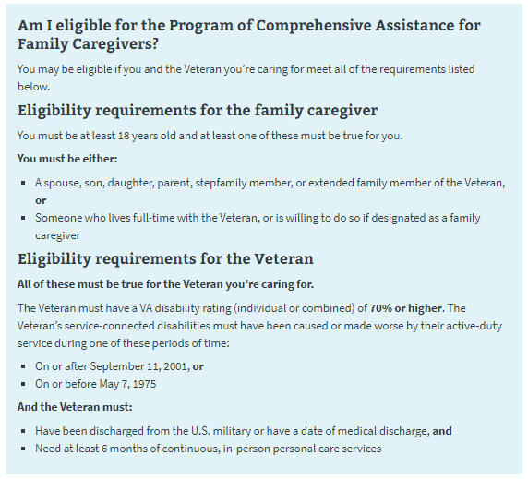  
*Figure 1. 10-10CG eligibility information.*

### **Navigation**

Begin the application at https://www.va.gov/family-and-caregiver-benefits/health-and-disability/comprehensive-assistance-for-family-caregivers/apply-form-10-10cg/introduction(see Figure 2).

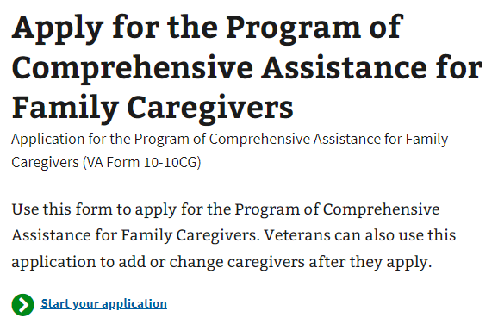  
  
*Figure 2. Beginning the application.*

Information about the program, as well as a link to the form, can be found on the Program of Comprehensive Assistance for Family Caregivers page (https://staging.va.gov/family-and-caregiver-benefits/health-and-disability/comprehensive-assistance-for-family-caregivers/). See Figure 3.

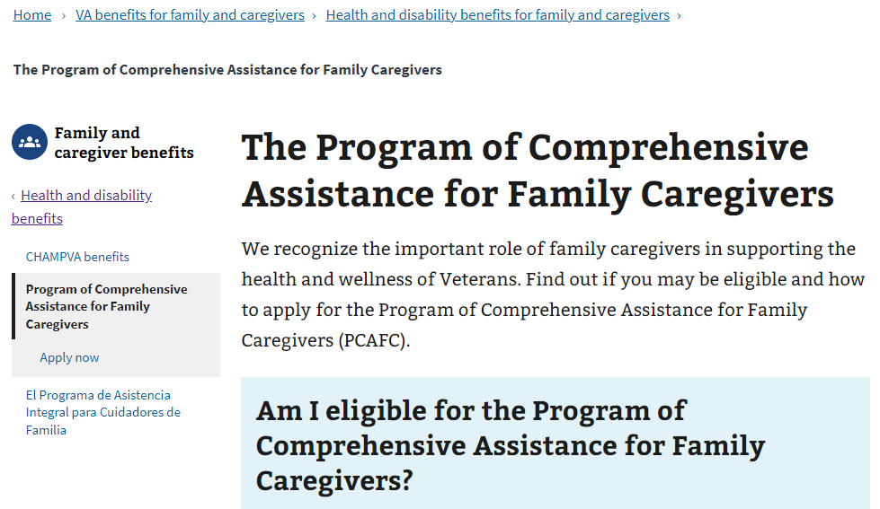

*Figure 3. Information on the Program of Comprehensive Assistance for Family Caregivers.*

### **Maintenance Windows**

The technical systems that support the online family caregiver application undergo occasional maintenance. During this time, any online submissions will not go through. When such a maintenance window is coming up within 1 hour, users who navigate to the online form will see this message (Figure 4), which specifies when the maintenance will begin and end:

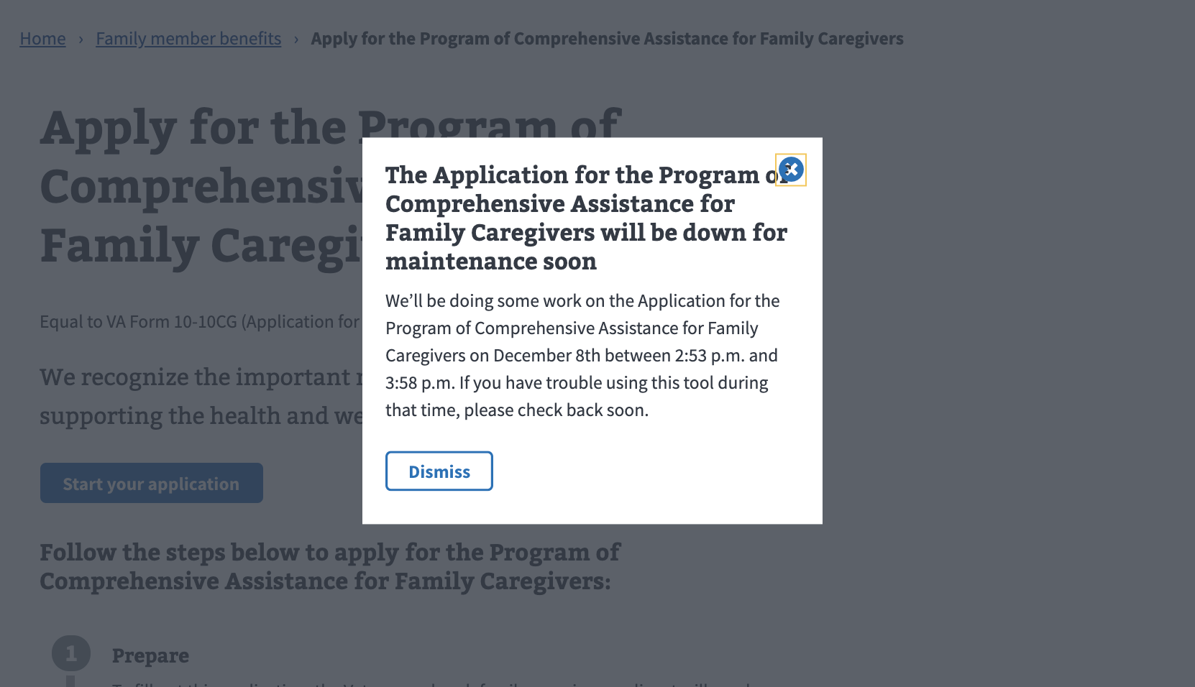  
*Figure 4. Notice of upcoming scheduled maintenance.*

If the user navigates to the form once a maintenance window is underway, they will see the following message (Figure 5), and will be unable to start the online application:

*Figure 5. Tool unavailable due to maintenance.*

# **How Do I Apply?**

The application page provides instructions on how to apply for the Program of Comprehensive Assistance for Family Caregivers and what information is needed to complete the form (Figure 6). This page also directs the user to the application once they are ready to apply.

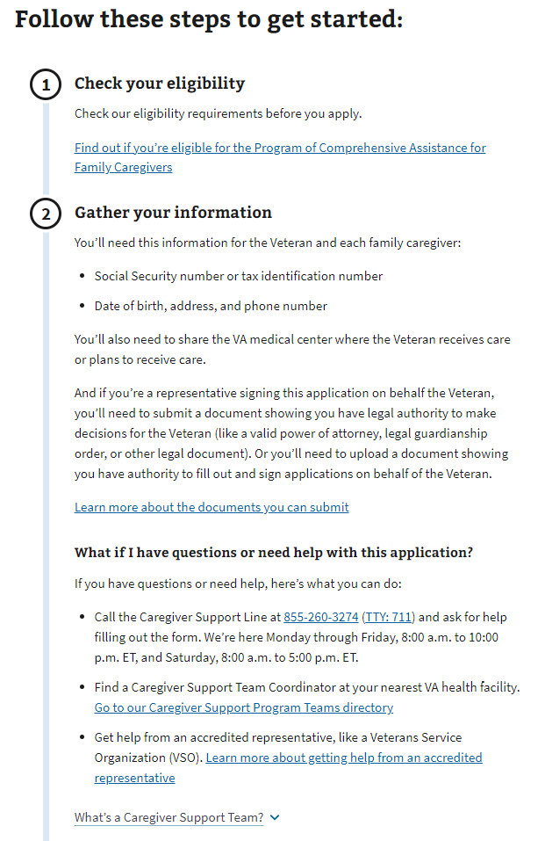

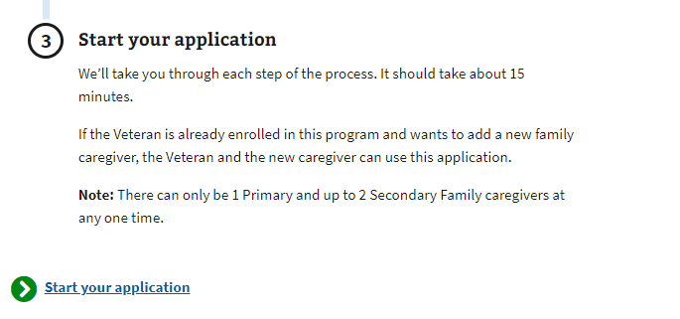

*Figure 6. Pre-application information for Program of Comprehensive Assistance for Family Caregivers.*

A drop-down link gives applicants additional information about the Caregiver Support Team (Figure 7).

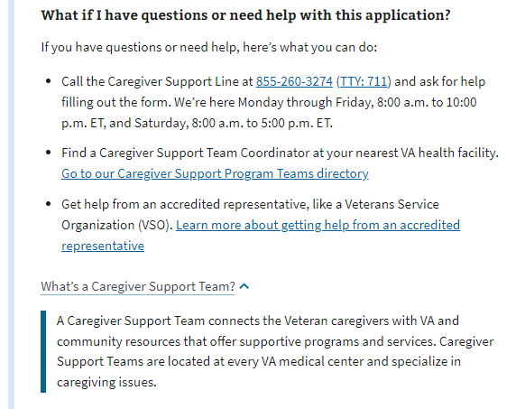  
*Figure 7. Caregiver Support Program Staff member information.*

# **Program of Comprehensive Assistance for Family Caregivers (PCAFC) Application**

### **Veteran Information**

First, the Veteran will be asked to fill in general personal information (Figure 8).

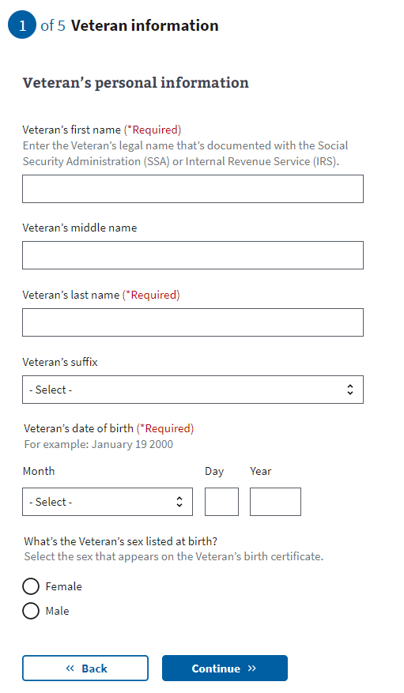

*Figure 8. General Veteran identification information for 10-10CG application.*

The application will tell the Veteran what must be filled in. If they do not enter all the required information, they will not be allowed to move on to the next page.

The Veteran’s Social Security number or tax information number is needed to process the 10-10CG form online (Figure 9). If they don’t supply a number, they will receive an error message.

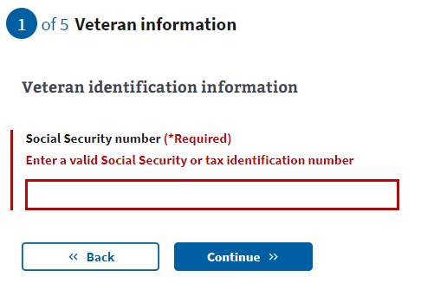

*Figure 9. Area where user enters Veteran’s Social Security or tax information.*

A Social Security number or tax identification number is not a requirement to apply or participate in the program. If the Veteran doesn’t want to supply their Social Security number or tax identification number, they can still apply to the program by downloading a copy of the form to fill out, sign, and send to VA via mail.

Next, the Veteran will be asked to fill in contact information (Figure 10).

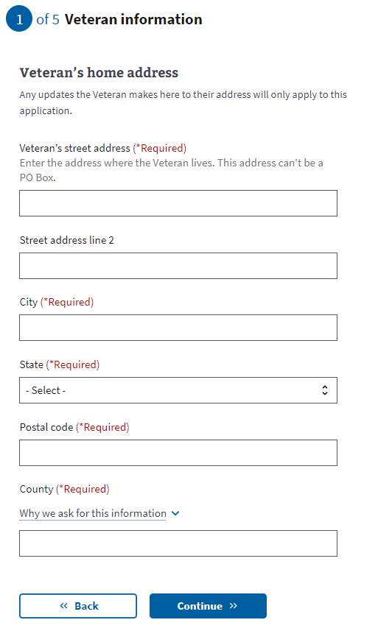

*Figure 10. Veteran contact information.*

The primary phone number (Figure 11) is required so a Facility Caregiver Support Program Staff member can contact the Veteran to discuss the application. Email is not a required field.

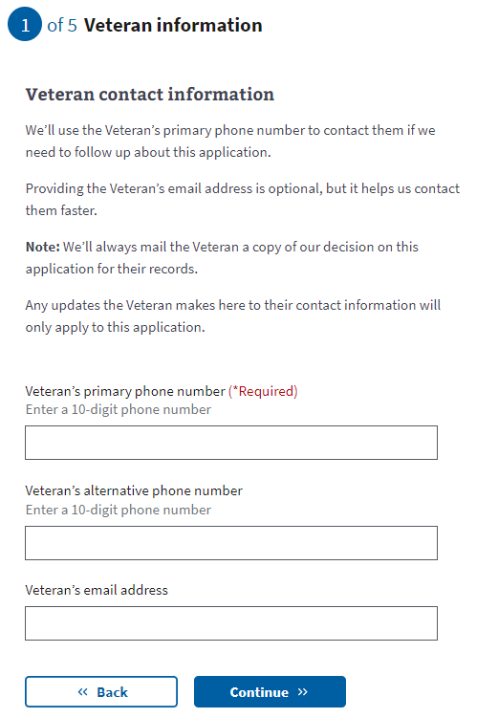

*Figure 11. Area for primary phone number.*

If they do not enter all the required information, they will not be allowed to move on to the next page.

### **Veteran Health Care Information**

*

The Veteran will be asked where they plan to receive VA health care (Figure 12). This is so the application can be reviewed by a Facility Caregiver Support Program Staff member at that location. This information is required to complete the form.

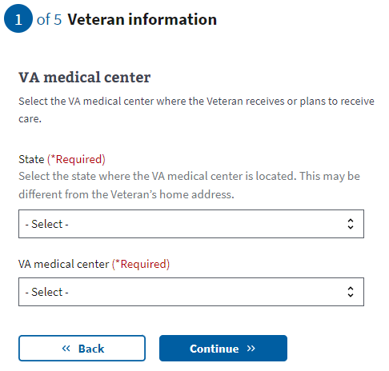

*Figure 12. Where the Veteran plans to receive care.*

### **Primary Family Caregiver Selection**

Next, the Veteran will be asked if they would like to apply for benefits for a Primary Family Caregiver (Figure 13). If Yes, the next step will be to add the Primary Family Caregiver Information. If No, the Veteran will skip to Secondary Family Caregiver Selection (Page 44) of this guide). The question must be answered to proceed.



*Figure 13. Applying for benefits for a primary caregiver.*

The definition of a Primary Family Caregiver can be accessed through a drop-down link (Figure 14).

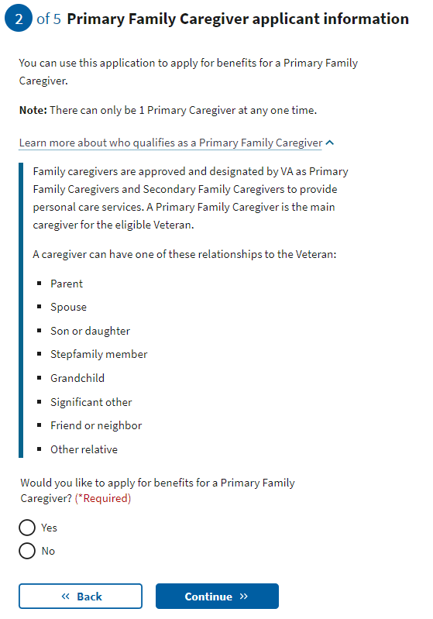*Figure 14. Definition of Primary Family Caregiver.*

### **Primary Family Caregiver Information**

If the Veteran is applying with a Primary Family Caregiver, the person applying to be the Primary Family Caregiver will be asked to enter general personal information (Figure 15).

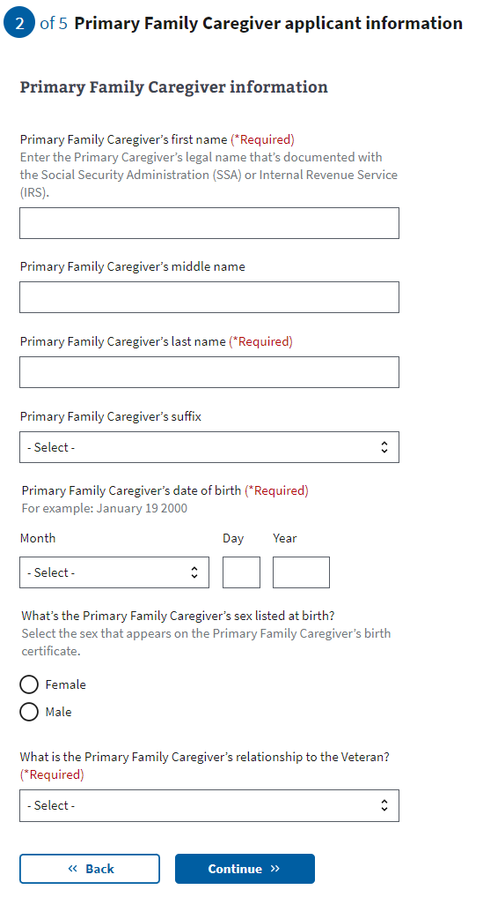  
*Figure 15. Primary Family Caregiver general information.*

The application will tell the Primary Family Caregiver what must be filled in. If they do not enter all the required information, they will not be allowed to move on to the next page.

The Primary Family Caregiver’s Social Security number or tax identification number is requested, but not required to apply for the program. The caregiver applicant will receive an error message if they put in a number that is not 9 digits, or if they repeat a number that has been entered elsewhere on the form (Figure 16).

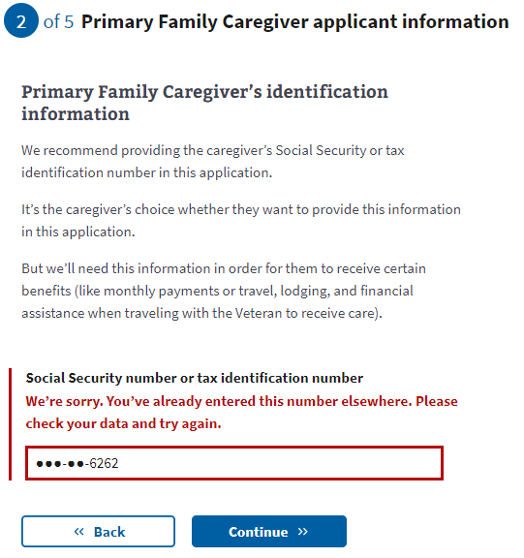  
*Figure 16. Social Security or tax ID number error.*

Next, the Primary Family Caregiver will be asked to fill in contact information, including home and mailing addresses (Figure 17).

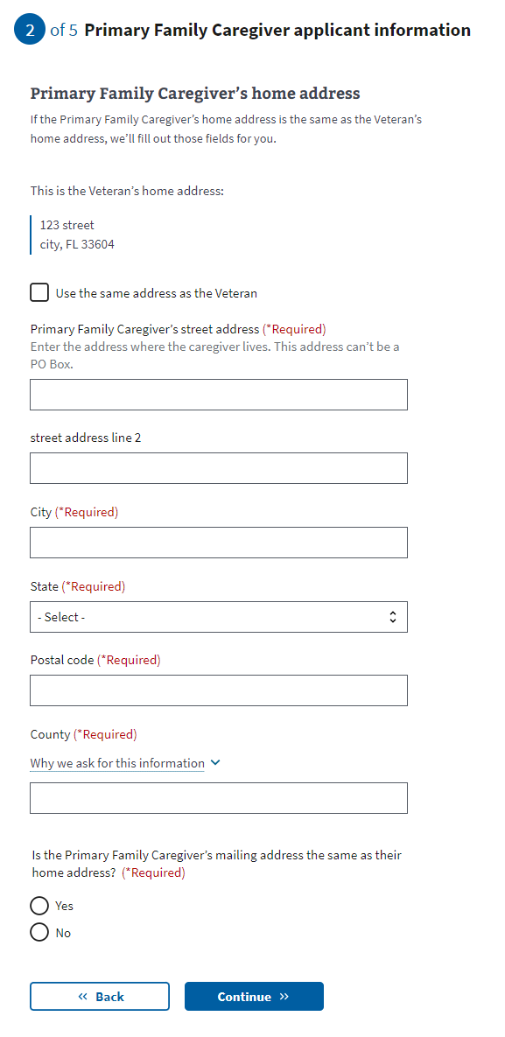  
*Figure 17. Caregiver contact information.*

If the Primary Caregiver’s home address is different from their mailing address, they will be asked to provide the mailing address (Figure 18).

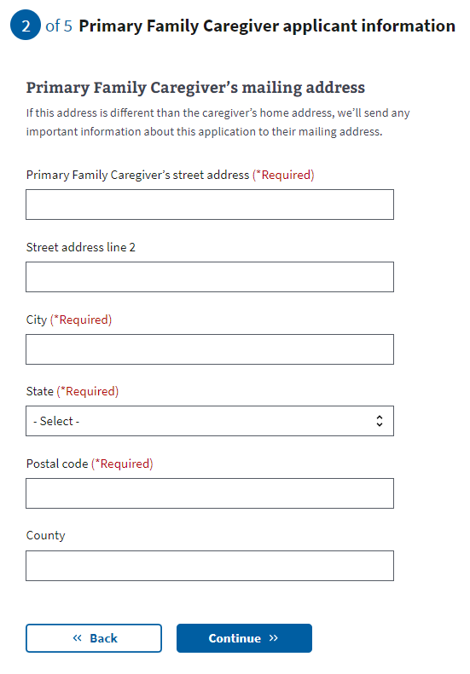

Figure 18. Caregiver mailing address

The primary phone number is required so a Facility Caregiver Support Program staff member can contact the Primary Family Caregiver to discuss the application (Figure 19). Email is not a required field.

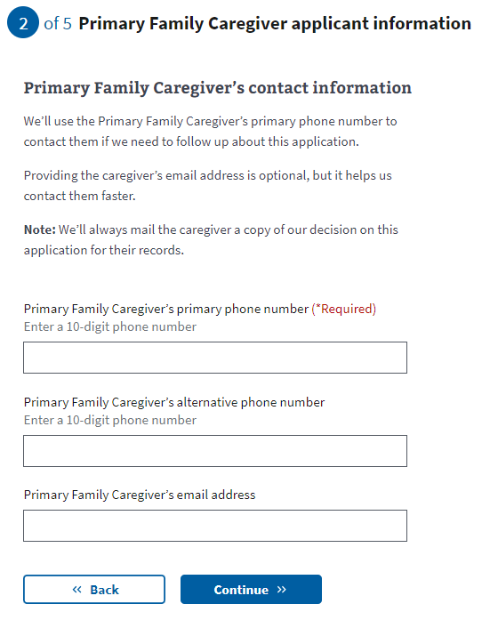

*Figure 19. Required caregiver phone number.*

### **Secondary Family Caregiver Selection**

Next, the Veteran will be asked if they would like to apply for benefits for a Secondary Family Caregiver (Figure 20). If Yes, the next step will be to add the Secondary Family Caregiver information. If there is a Primary Family Caregiver on the application, Secondary Family Caregivers are optional. Each Veteran can have up to 1 Primary Family Caregiver and 2 Secondary Family Caregivers. If there is no Primary Family Caregiver on the application, the Veteran will need to add Secondary Family Caregiver(s).

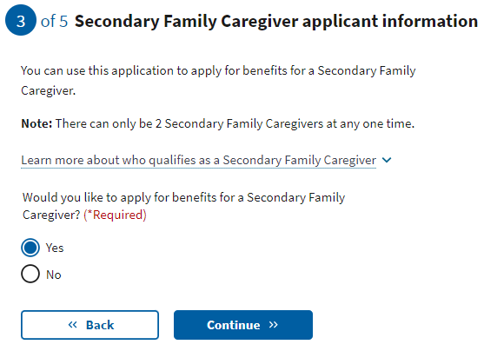

*Figure 20. Secondary Family Caregiver.*

The definition of a Secondary Family Caregiver can be accessed by clicking the drop-down link (Figure 21).

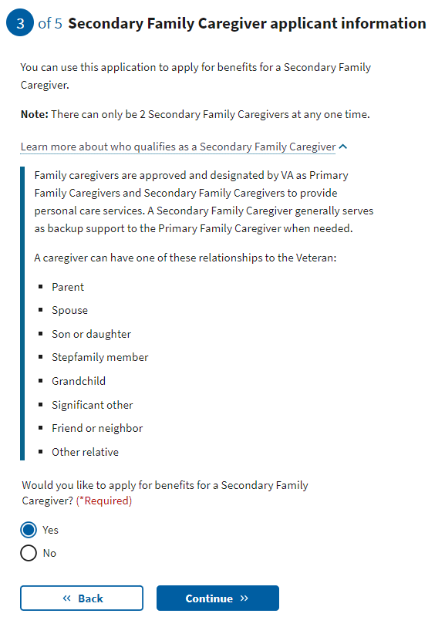

*Figure 21. Secondary Family Caregiver definition.*

If the application has a Primary Family Caregiver and they do not add a Secondary Family Caregiver, they will advance to the review screen.

If the application does not have a Primary Family Caregiver and they do not add a Secondary Family Caregiver, they see this error message (Figure 22):

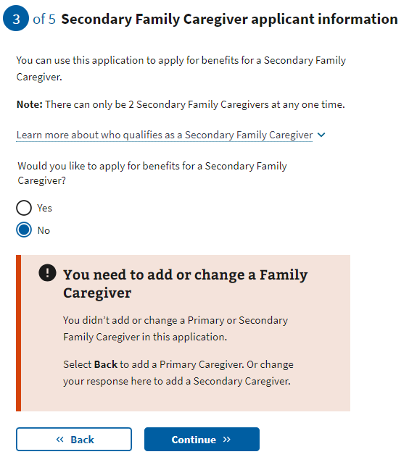  
*Figure 22. Family Caregiver listing error.*

### **Secondary Family Caregiver Information**

If the applicants add a Secondary Family Caregiver, additional fields will appear.

The person applying to be the Secondary Family Caregiver will be asked to enter general personal information (Figure 23).

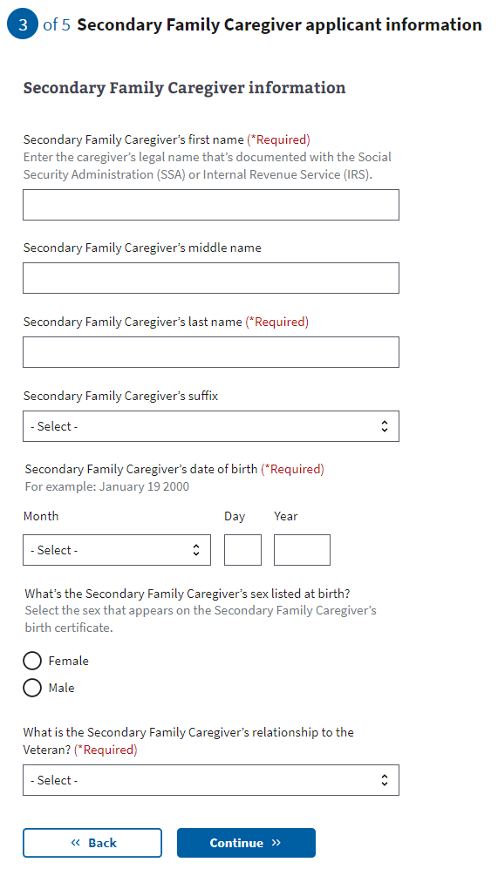  
*Figure 23. Secondary Family Caregiver general information.*

The application will tell the Secondary Family Caregiver what must be filled in. If they do not enter all the required information, they will not be allowed to move on to the next page.

The Secondary Family Caregiver’s Social Security number or tax identification number is requested, but not required to apply for the program. The caregiver applicant will receive an error message (Figure 24) if they put in a number that is not 9 digits, or if they repeat a number that has been entered elsewhere on the form.



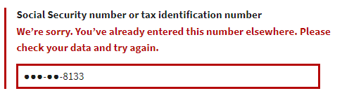  
*Figure 24. Error with Secondary Family Caregiver’s Social Security or tax ID number.*

Next, the Secondary Family Caregiver will be asked to fill in contact information, including mailing and home address (Figure 25).

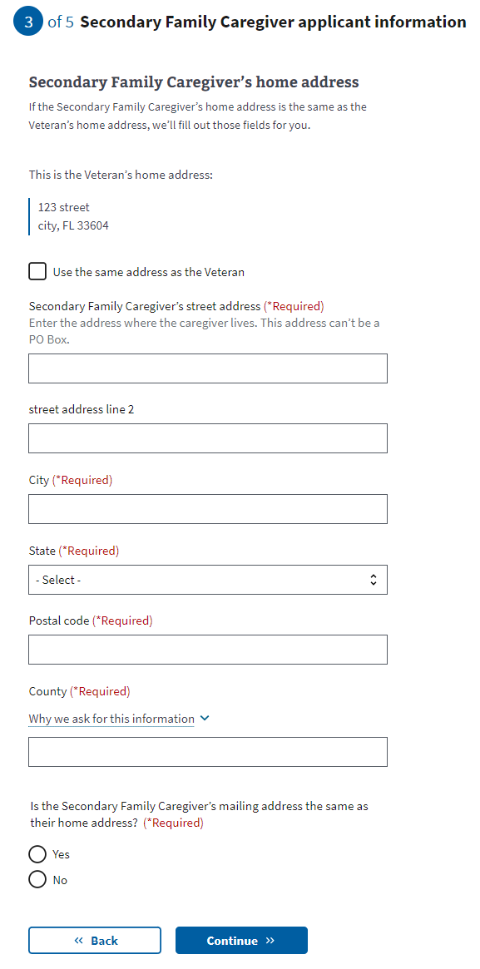  
*Figure 25. Secondary caregiver contact info.*

If the Secondary Caregiver’s home address is different from their mailing address, they will be asked to provide the mailing address (Figure 26).

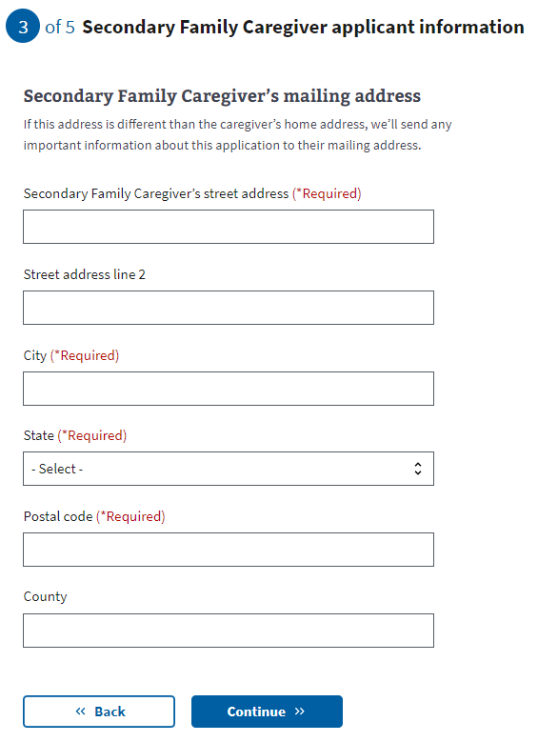

Figure 26. Secondary caregiver contact info.

Primary phone number is required so a Facility Caregiver Support Program Staff member can contact the Secondary Family Caregiver to discuss the application (Figure 27). Email is not a required field.

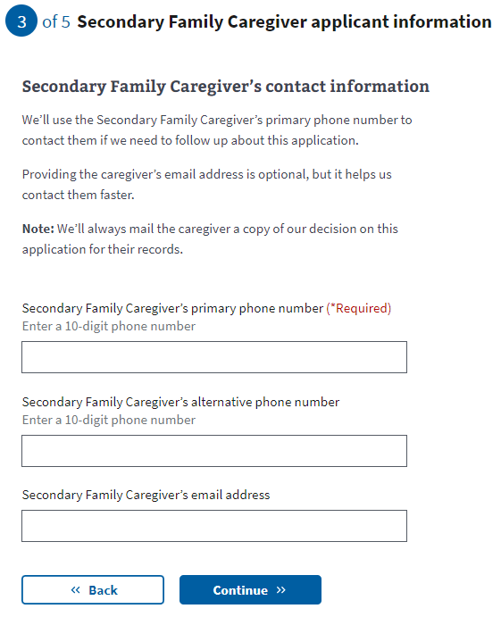

*Figure 27. Secondary caregiver phone number.*

Applicants are then asked if they would like to add an additional Secondary Family Caregiver (Figure 28). If the applicants do not add an additional Secondary Family Caregiver, they will advance to the review screen.

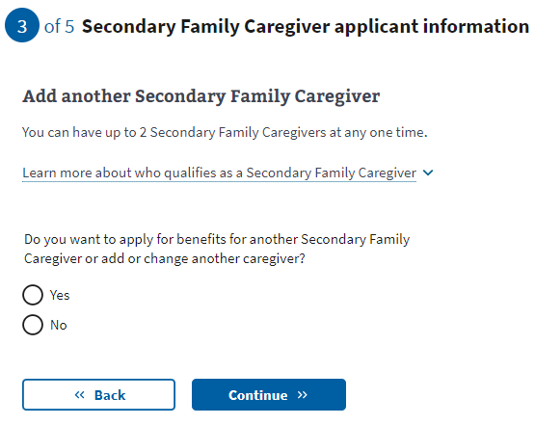  
*Figure 28. Option to add an additional Secondary Family Caregiver.*

If they add an additional Secondary Family Caregiver, they will advance to a new screen.

### Additional **Secondary Family Caregiver Information**

Next, the person applying to be the Additional Secondary Family Caregiver will be asked to enter general personal information (Figure 29).

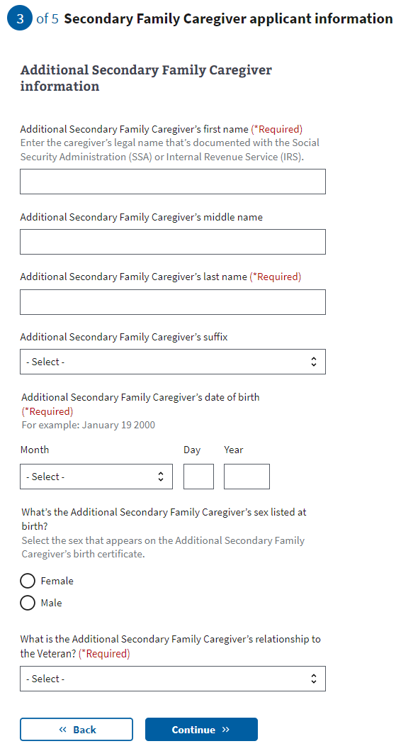  
*Figure 29. Additional Secondary Family Caregiver information.*

The application will tell the Additional Secondary Family Caregiver what must be filled in. If they do not enter all the required information, they will not be allowed to move on to the next page.  
  
The Additional Secondary Family Caregiver’s Social Security number or tax identification number is requested, but not required to apply for the program. The caregiver applicant will receive an error message (Figure 30) if they put in a number that is not 9 digits, or if they repeat a number that has been entered elsewhere on the form.

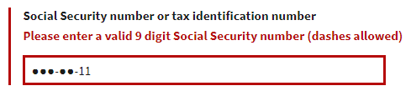

*Figure 30. Additional Secondary Family Caregiver, Social Security, or tax ID number error.*

Next, the Additional Secondary Family Caregiver will be asked to fill in contact information, including home and mailing address (Figure 31).

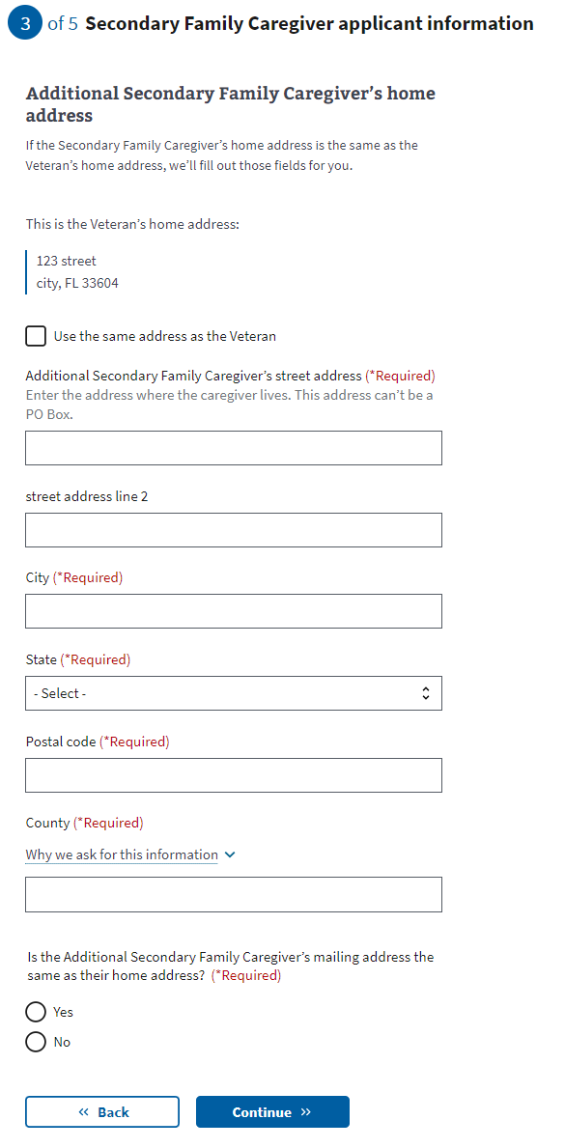

*Figure 31. Additional Secondary Family Caregiver contact information.*

If the Additional Secondary Caregiver’s home address is different from their mailing address, they will be asked to provide the mailing address (Figure 32).

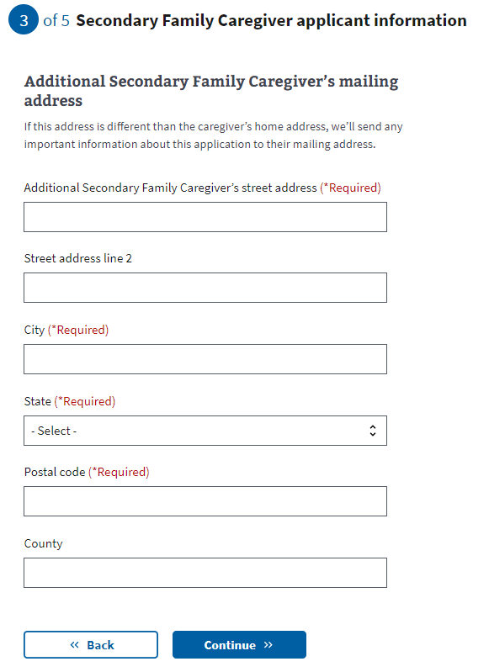

Figure 32. Additional Secondary Family Caregiver mailing address.

A primary phone number is required so a Facility Caregiver Support Program Staff member can contact the Additional Secondary Family Caregiver to discuss the application (Figure 33). Email is not a required field.

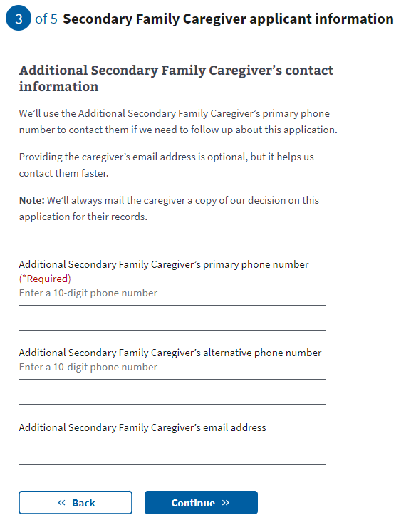  
*Figure 33. Additional Secondary Family Caregiver primary phone number.*

### **Representative Documentation**

Next, the applicant is asked whether they will be signing the application or if their legal representative will. If they indicate that the Veteran will be signing the application, they will advance to the review screen.

If they indicate that a legal representative will be signing the application, they will be required to share legal representative documentation (Figure 34). This documentation is required if someone other than the Veteran will be signing the application.

*Figure 34. Question regarding who will sign the application.*

The requirements for legal documentation (Figure 35) can be accessed through a drop-down link.

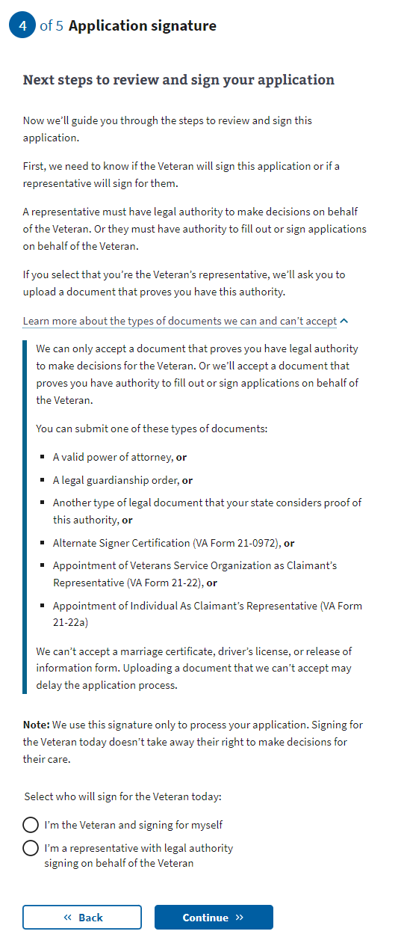

*Figure 35. Requirements for legal documentation.*

**Upload your supporting documentation**

If the applicant indicates the application will be signed by their legal representative, they will be taken to the Upload your supporting document screen (Figure 36). Using the “Upload file” button, applicants can upload a PDF, JPEG, or PNG with a maximum file size of 10 MB.

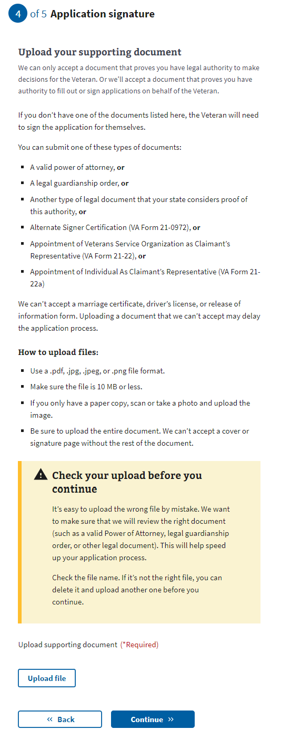

*Figure 36. Uploading legal representative documentation.*

The applicant will see a confirmation if the file has been successfully uploaded, and will be directed to confirm the file name to ensure it is the correct document (Figure 37). They can delete the file if it is not the correct document.

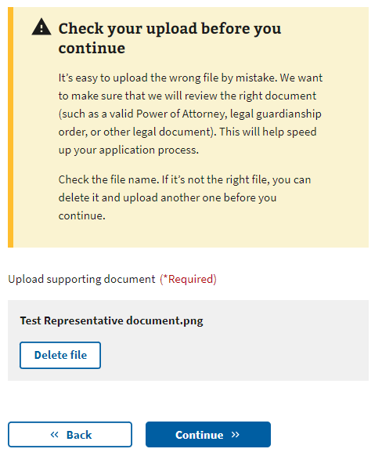  
*Figure 37. File upload confirmation.*

**File Upload Errors**

If there is a problem uploading a file, an error message will be displayed.

**Network Issue**

If a network issue occurs that prevents the file from being uploaded, they will receive an error (Figure 38a) and are instructed to try again. Note that the error may be caused by issues within the VA network or issues on the user’s computer or Internet connection. If so, they may need to try again multiple times or try at a later time.

*Figure 38a. File upload error – Network Issue.*

**File Too Large**

If the file size is larger than 10 MB, they will receive an error (Figure 38b) and are instructed to upload a smaller file.

*Figure 38b. File upload error – File too large.*

**File Too Small**

If the file size is too small, they will receive an error (Figure 38c) and are instructed to upload a larger file. Note that the file they are trying to upload may in fact be corrupt. If this error occurs multiple times with the same file, it may be best to try a different file or different file format.

*Figure 38c. File upload error – File too small.*

**Wrong File Type**

If the file is not one of the supported file types (.pdf, .jpeg, .jpg, or .png), they will receive an error (Figure 38d) and are instructed to upload a supported file type. Note some browsers will block the applicant from uploading a file that is not supported. If an applicant gets stuck on this error, it would be useful to help them save the file in another format.

*Figure 38d. File upload error – Wrong file type.*

# **Review and Submission**

### **Reviewing the Application**

The last step is the review application page (Figure 39). Here, the Veteran and each Family Caregiver can review the information that they’ve entered by clicking on each plus sign next to a section:

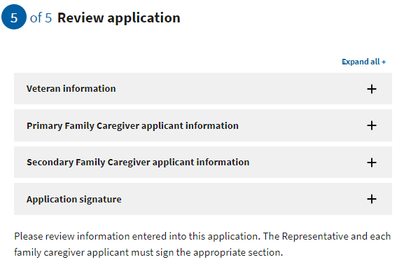  
*Figure 39. The review application page.*

If the Veteran and each caregiver applicant clicks on the plus sign, the section will open and show what the user entered (Figure 40). If something looks wrong, the applicant can select the “edit” button, and will be able to change the information. To save changes after editing, select the “update page” button.

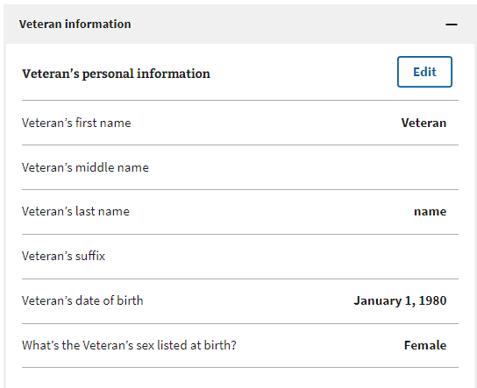

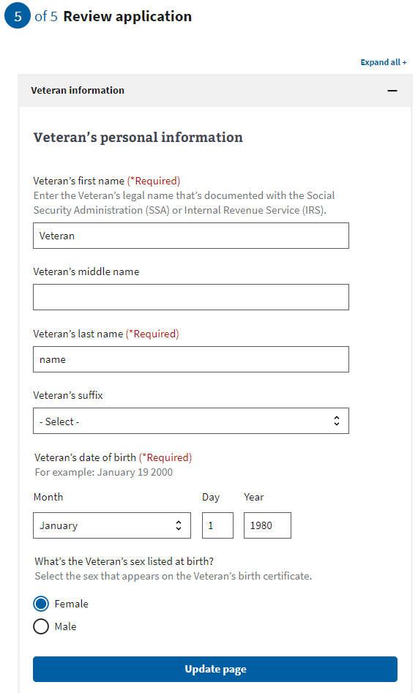

*Figure 40. Expanding Veteran and caregiver information sections.*

### **Signature Section**

Once the Veteran and each caregiver applicant has reviewed the information and made any changes, they can proceed to the signature section. The Veteran’s statement of truth (Figure 41) will populate depending on what the applicant chose on the Representative documentation screen. If the applicant indicated that the Veteran will be signing the application, they will be shown this screen. The Veteran can type their full name as they input it into the form and select the “I certify the information is correct and true to the best of my knowledge and belief” checkbox.

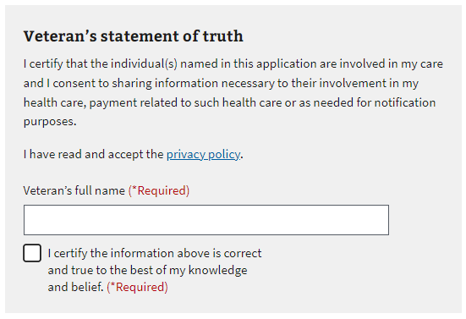  
*Figure 41. Veteran’s statement of truth.*

If the name does not match the name input into the form, they will receive this error (Figure 42). Within the error, they can see the name input in the form. They can edit the typed signature name and select the “I certify the information is correct and true to the best of my knowledge and belief” checkbox again.

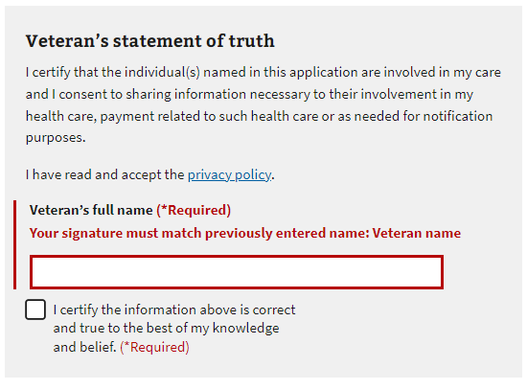  
*Figure 42. Signature error.*

If the applicant chose “I’m a representative with legal authority signing on behalf of the Veteran” on the Representative documentation screen, they will see this screen (Figure 43). The representative can input their full name and select the “I certify the information is correct and true to the best of my knowledge and belief” checkbox.

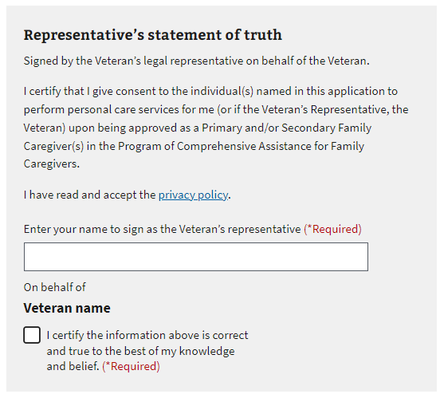  
*Figure 43. Signing on behalf of the Veteran.*

Next, each caregiver applicant can type their full name as they input it into the form and select the “I certify the information is correct and true to the best of my knowledge and belief” checkbox (Figure 46).

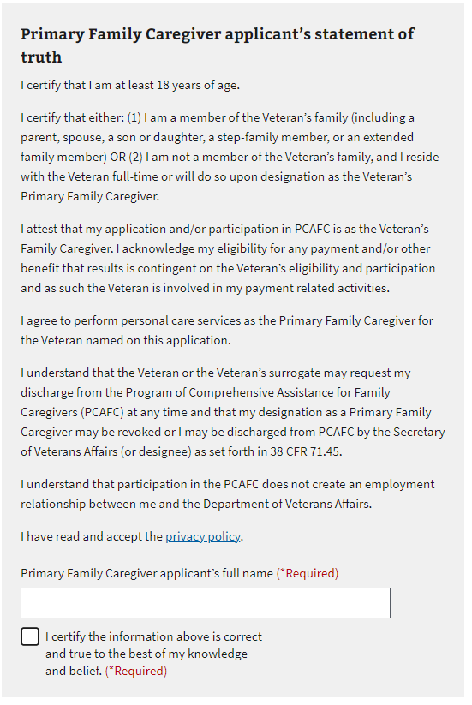  
*Figure 44. Primary caregiver’s statement of truth.*

If the name does not match the name input into the form, they will receive this error (Figure 45). Within the error, they can see the name that was input earlier in the form. They can edit the name and select the “I certify the information is correct and true to the best of my knowledge and belief” checkbox again.

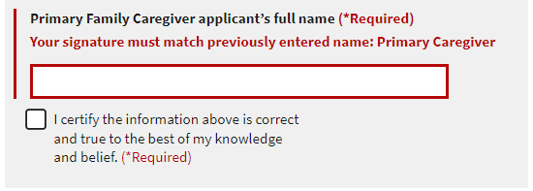  
*Figure 45. Primary Family Caregiver signature error.*

### **Submitting the Application**

Once the Veteran and each caregiver applicant has input their names, they can select to submit their application (Figure 46).

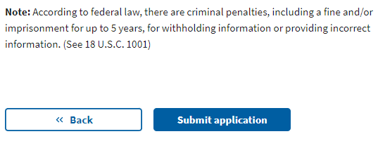  
*Figure 46. Submit the application.*

After selecting “submit application,” the applicants will be shown the below page (Figure 47) which contains a summary of the information, as well as additional information links that can help them understand the process for their application. They will also be able to print out the verification page and a copy of the submitted form to keep for their records.

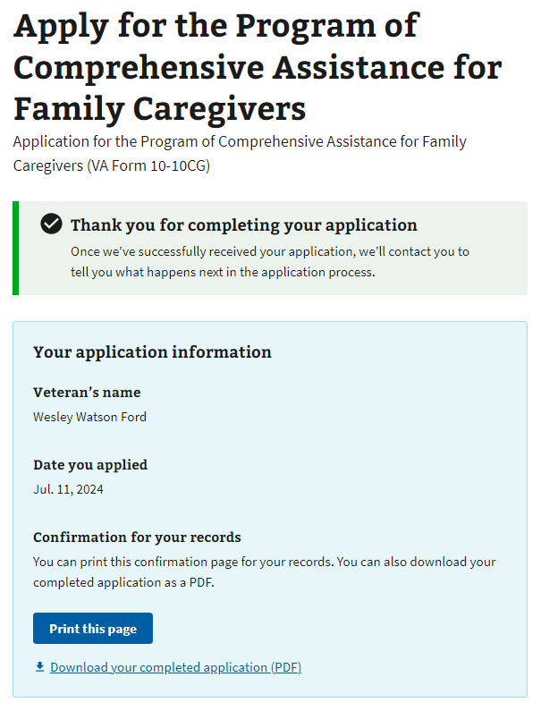

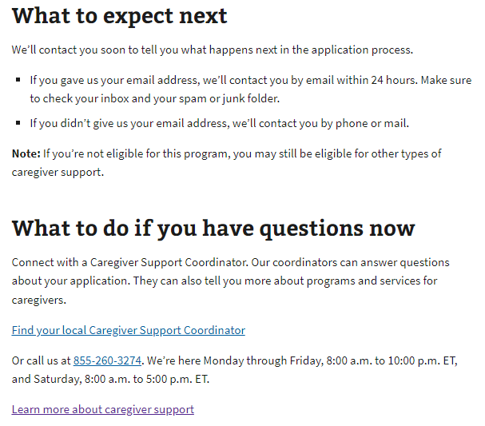

*Figure 47. Information summary.*

### **Troubleshooting a Submission Error**

If the application fails to submit, the applicant will receive the following error message (Figure 48) on the Review and Submission page.

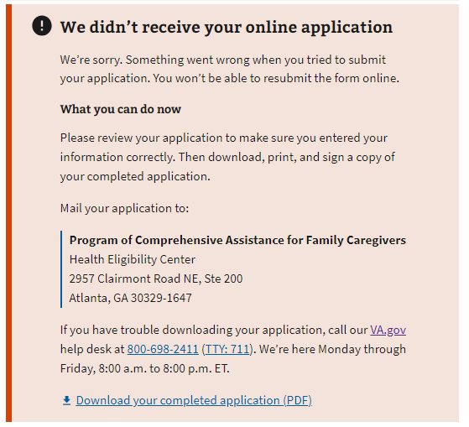  
*Figure 48. Application submission failure.*

If the applicant receives this error, they can carefully review the information submitted. If they see an error, they can fix it in the “review” field.

They will not be able to resubmit their online application unless they close their browser and start a new session. However, they can click the “download your completed application (PDF)” link at the bottom of the error message. The completed PDF will be saved to their computer.

Once they print out the completed PDF, the Veteran and each of the Family Caregiver applicants will need to checkmark the acknowledgment and sign. The application can be mailed to the address listed in the error message.

If the applicant tries to download the PDF but it fails to generate, applicants will receive one of two error messages:

**Error message 1:** (Code 400): Applicants will receive this message if there is an error generating the PDF (Figure 49).

  
*Figure 49. Form could not be downloaded.*

**Error message 2:** (Code 500): Applicants will receive this message if there is a failure on the VA.gov back end (Figure 50). Applicants receiving this message can try to submit the form later.

  
*Figure 50. VA.gov back-end failure.*

# **Table of Figures**

*Figure 1. 10-10CG eligibility information.*  
*Figure 2. Beginning the application.  
Figure 3. Information on the Program of Comprehensive Assistance for Family Caregivers..  
Figure 4. Notice of upcoming scheduled maintenance.  
Figure 5. Tool unavailable due to maintenance.  
Figure 6. Pre-application information for Program of Comprehensive Assistance for Family Caregivers.  
Figure 7. Caregiver Support Program Staff member information.  
Figure 8. General Veteran identification information for 10-10CG application.  
Figure 9. Area where user enters Veteran’s Social Security or tax information.  
Figure 10. Veteran contact information.  
Figure 11. Area for primary phone number.  
Figure 12. Where the Veteran plans to receive care.  
Figure 13. Applying for benefits for a primary family caregiver.  
Figure 14. Definition of primary caregiver.  
Figure 15. Primary Family Caregiver general information.  
Figure 16. Social Security or tax ID number error.  
Figure 17. Caregiver contact information.  
Figure 18. Caregiver mailing address*

*Figure 19. Required caregiver phone number.  
Figure 20. Secondary Family Caregiver.  
Figure 21. Secondar Family Caregiver definition.  
Figure 22. Family Caregiver listing error.  
Figure 23. Secondary Family Caregiver general information.  
Figure 24. Error with Secondary Family Caregiver’s Social Security or tax ID number.  
Figure 25. Secondary caregiver contact info.*

*Figure 26. Caregiver mailing address  
Figure 27. Secondary caregiver phone number.  
Figure 28. Option to add an additional Secondary Family Caregiver.  
Figure 29. Additional Secondary Family Caregiver information.  
Figure 30. Additional Secondary Family Caregiver, Social Security, or tax ID number error.  
Figure 31. Additional Secondary Family Caregiver contact information.*

*Figure 32. Additional Secondary Family Caregiver mailing address.Figure 33. Additional Secondary Family Caregiver primary phone number.  
Figure 34. Question regarding legal representative documents.  
Figure 35. Types of legal representative documents accepted.  
Figure 36. Uploading legal representative documentation.  
Figure 37. File upload confirmation.  
Figure 38a. File upload error – Network Issue.  
Figure 38b. File upload error – File too large.  
Figure 38c. File upload error – File too small.  
Figure 38d. File upload error – Wrong file type.  
Figure 39. The review application page.  
Figure 40. Expanding Veteran and caregiver information sections.  
Figure 41. Veteran’s statement of truth.  
Figure 42. Signature error.  
Figure 43. Signing on behalf of the Veteranent.  
Figure 44. Primary caregiver’s statement of truth.  
Figure 45. Primary Family Caregiver signature error.  
Figure 46. Submit the application.  
Figure 47. Information summary.  
Figure 48. Application submission failure.  
Figure 49. Form could not be downloaded.  
Figure 50. VA.gov back-end failure.*

# **Revision History**

| Version | Date | Author | Changes |
| --- | --- | --- | --- |
| 1.0.0 | 04/29/2021 | Dené Gabaldón | Initial version |
| 1.1.0 | 05/26/2021 | Alayna Abel | Revision for Sign-as-a-Representative release |
| 1.1.1 | 07/09/2021 | Chris Dyer | Improved file upload error messaging |
| 1.1.2 | 06/09/2022 | Mark Fallows | Revision for Sign-as-a-Representative update |
| 1.2 | 7/11/2023 | Heather Justice | Revision for web components and new fields |